**IMPORTANCE OF DIGITAL MARKETING FOR SMALL SCALE INDUSTRIES**

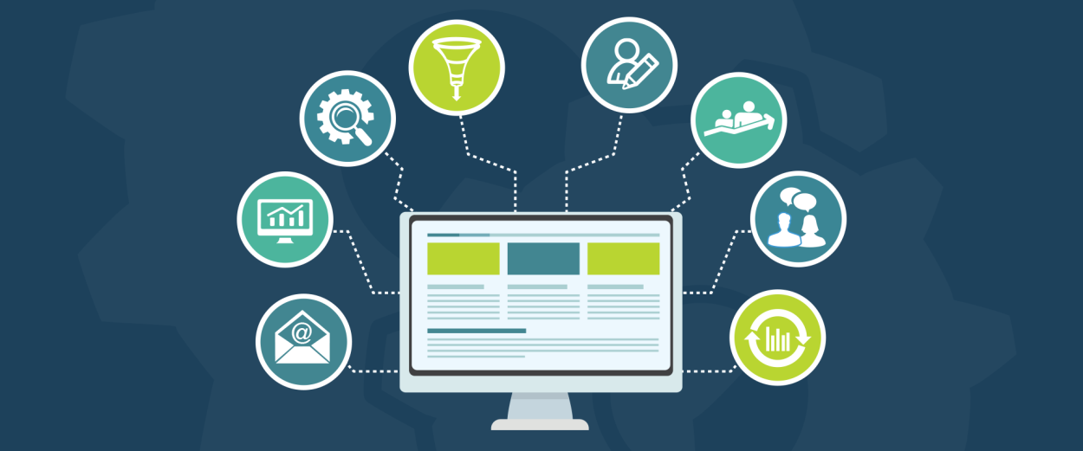

Digital marketing plays an important and very significant role in any industry may it be a large scale or any small scale. Digital marketing is all about various techniques and marketing strategies that can be followed online to strengthen any industry’s networks.

Though it is important in both small and large scale ones, small scale ones being the growing ones can be highly benefitted by digital marketing. As a growing forum needs the strongest approaches and measures to be undertaken to mark their territories and conquer the market, digital marketing proves out to be the most important and efficient way one may follow to achieve the same!

Digital marketing has many benefits some of which I consider to be important for consideration are the followings:

* **Helps attract more customers.** Since in today’s era, most or we can say almost the whole of the public is available online via different networking sites. In such a generation, hitting the public is more easier online then doing that offline via pamphlets, magazines, posters, etc.
* **Competitors are growing online already.** Small scale industries are the ones that are just set up and need to develop and conquer the market, and all of the competitors ( actually every small or large scale setup) have already started developing their markets online. Since the competitors have already marked their positions via online networks, the upcoming ones need to adopt this tool to attract the public attention as no matter we read the newspaper a day or not but we must check out our social media profiles and advertising there gives a business a place in people’s minds.
* **Contacts between business and customers get easier.** While using digital marketing techniques, the business directly or indirectly ensures that reaching out to them via different platforms gets easier for the general public and the business also, solving the queries and issues of people becomes easier and lesser time consuming then personally dealing and visiting the customers. This ensures a better outcome and opportunities for the business.
* **Data analysis is easier online.** The ease in data analysis that comes with online approaches helps generate strategies to hit the public and get to their recommendation lists for more customer attractions.
* **It is cost-saving.** Online marketing could be started with a small budget and then adding on to the budget as the market of the industry grows. A business may also start its marketing with just via social media which is minimal to no cost requiring.
* **Increases an industry’s level.** As the industry starts dealing with digital marketing, its level automatically starts increasing and it starts conquering the market with just its advertising techniques present online.

These were the few benefits that I think are associated with digital marketing and its techniques and how it benefits every industry in its growth and development. Digital marketing plays a crucial role in the industry to mark its territory in the growing market in today’s era.